**LAPORAN PRAKTIKUM INTERNET OF THINGS (IoT)**

**Fakultas Vokasi, Universitas Brawijaya**

**Membuat Tampilan Interface**

**Web Dashboard IoT**

*Ramadhani Maulana Raharjo – 233140701111025*

*Fakultas Vokasi, Universitas Brawijaya*

*Email :* [*ramadhanimr04@student.ub.ac.id*](mailto:ramadhanimr04@student.ub.ac.id)

**Abstract**

Perkembangan Internet of Things (IoT) menuntut tersedianya sistem pemantauan data yang efisien dan mudah diakses. Dalam proyek ini, dikembangkan sebuah tampilan antarmuka web dashboard berbasis Laravel 11 yang berfungsi untuk menampilkan dan memvisualisasikan data sensor dari sistem IoT secara *real-time*. Proses pembangunan melibatkan penggunaan Laravel 11 sebagai *framework* utama, Visual Studio Code sebagai editor, serta XAMPP dan phpMyAdmin untuk pengelolaan basis data. Dashboard ini menampilkan grafik interaktif menggunakan Chart.js, memungkinkan pengguna melihat perbandingan dua nilai sensor dan mengunduh data dalam format Excel. Hasil implementasi menunjukkan bahwa dashboard berhasil menyajikan data sensor secara dinamis, responsif, dan informatif, sehingga dapat membantu pengguna dalam memantau kondisi lingkungan atau sistem berbasis IoT dengan lebih baik.

*Keywords* : Laravel 11, *Internet of Things*, *Dashboard,* Visualisasi Data, Chart.js

1. **Introduction**
   1. Latar Belakang

Internet of Things (IoT) merupakan konsep teknologi yang memungkinkan perangkat fisik saling terhubung melalui jaringan internet untuk mengumpulkan, mengirim, dan menganalisis data secara otomatis. Dalam penerapannya, IoT banyak digunakan di berbagai sektor seperti industri, pertanian, kesehatan atau sistem secara real-time. Namun, data yang dikumpulkan dari perangkat IoT akan sulit dianalisis jika tidak disajikan dalam bentuk yang mudah dipahami.

Oleh karena itu, dibutuhkan sebuah sistem antarmuka atau dashboard yang mampu menyajikan data sensor dari perangkat IoT secara visual, dinamis, dan informatif. Salah satu solusi untuk membangun dashboard ini adalah dengan menggunakan Laravel, framework PHP yang modern, efisien, dan memiliki banyak dukungan library. Pada proyek ini, Laravel 11 digunakan untuk membangun sebuah web dashboard yang terintegrasi dengan basis data, serta mampu menampilkan grafik data sensor secara interaktif menggunakan Chart.js. Dengan adanya dashboard ini, pengguna dapat dengan mudah memantau dan menganalisis data dari sistem IoT yang mereka miliki.

* 1. Tujuan Eksperimen

1. Menampilkan data sensor secara real-time dalam bentuk grafik interaktif menggunakan Chart.js, sehingga pengguna dapat membandingkan performa dua sensor secara visual.
2. Menyediakan informasi statistik penting seperti rata-rata nilai sensor dan tingkat korelasi antar sensor, guna mempermudah analisis kondisi sistem.
3. Memberikan visualisasi perubahan data sensor antar periode waktu (24 jam, 7 hari, 30 hari), agar pengguna dapat memantau tren atau anomali secara fleksibel.
4. Menyediakan fitur ekspor data ke Excel agar data yang ditampilkan dapat disimpan atau digunakan untuk kebutuhan dokumentasi dan pelaporan lebih lanjut.
5. Menghasilkan tampilan antarmuka yang modern, responsif, dan mudah digunakan, dengan navigasi yang intuitif bagi pengguna dalam melakukan pemantauan sistem berbasis IoT.
6. **Methodology**
7. Tools & Materials

Laptop, Visual Studio Code, Laravel 11, XAMPP, phpMyAdmin, dan koneksi internet.

1. **Implementation Steps** 
   * + 1. Buka folder laravel yang sudah dibuat pada Praktik 12 pada VSCode

Buka terminal dan jalankan code berikut:

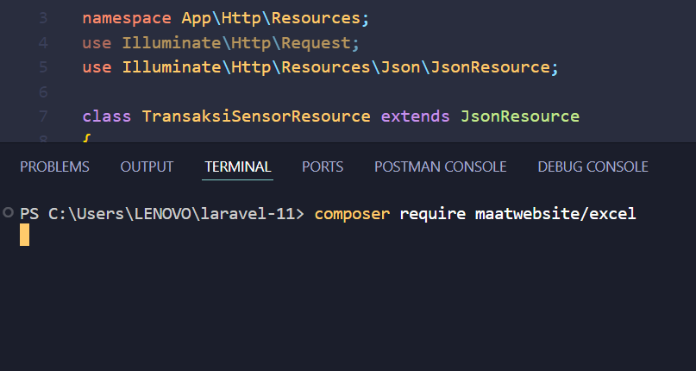

* + - 1. Setelah itu ketikan pada terminal: php artisan make:controller GraphController

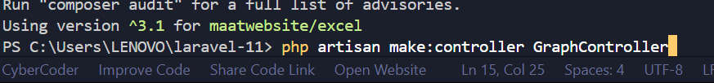

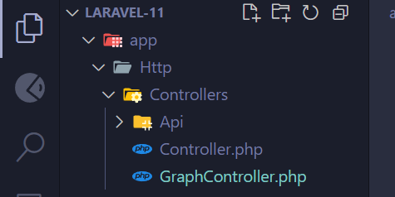

* + - 1. Kemudian tambahkan code berikut pada GraphController

<?php

namespace App\Http\Controllers;

use App\Exports\TransaksiSensorExport;

use Maatwebsite\Excel\Facades\Excel;

use App\Models\TransaksiSensor;

class GraphController extends Controller

{

    /**

     * Menampilkan grafik transaksi sensor.

     *

     * @return \Illuminate\View\View

     */

    public function index()

    {

        // Mengambil data transaksi sensor

        $transaksiSensors = TransaksiSensor::latest()->take(10)->get();

        // Mengambil data label

        $labels = $transaksiSensors->pluck('nama_sensor');

        // Mengambil data nilai1 dan nilai2 untuk grafik

        $dataNilai1 = $transaksiSensors->pluck('nilai1');

        $dataNilai2 = $transaksiSensors->pluck('nilai2');

        return view('graph', compact('labels', 'dataNilai1', 'dataNilai2'));

    }

    /**

     * Mengunduh data transaksi sensor dalam format Excel

     *

     * @return \Symfony\Component\HttpFoundation\BinaryFileResponse

     */

    public function exportToExcel()

    {

        return Excel::download(new TransaksiSensorExport, 'transaksi_sensor.xlsx');

    }

}

* + - 1. Setelah itu, jalankan perintah ini pada terminal :



* + - 1. Setelah itu tambahkan code berikut pada GraphController :

<?php

namespace App\Http\Controllers;

use App\Exports\TransaksiSensorExport;

use Maatwebsite\Excel\Facades\Excel;

use App\Models\TransaksiSensor;

class GraphController extends Controller

{

    /**

     * Menampilkan grafik transaksi sensor.

     *

     * @return \Illuminate\View\View

     */

    public function index()

    {

        // Mengambil data transaksi sensor

        $transaksiSensors = TransaksiSensor::latest()->take(10)->get();

        // Mengambil data label

        $labels = $transaksiSensors->pluck('nama_sensor');

        // Mengambil data nilai1 dan nilai2 untuk grafik

        $dataNilai1 = $transaksiSensors->pluck('nilai1');

        $dataNilai2 = $transaksiSensors->pluck('nilai2');

        return view('graph', compact('labels', 'dataNilai1', 'dataNilai2'));

    }

    /**

     * Mengunduh data transaksi sensor dalam format Excel

     *

     * @return \Symfony\Component\HttpFoundation\BinaryFileResponse

     */

    public function exportToExcel()

    {

        return Excel::download(new TransaksiSensorExport, 'transaksi_sensor.xlsx');

    }

}

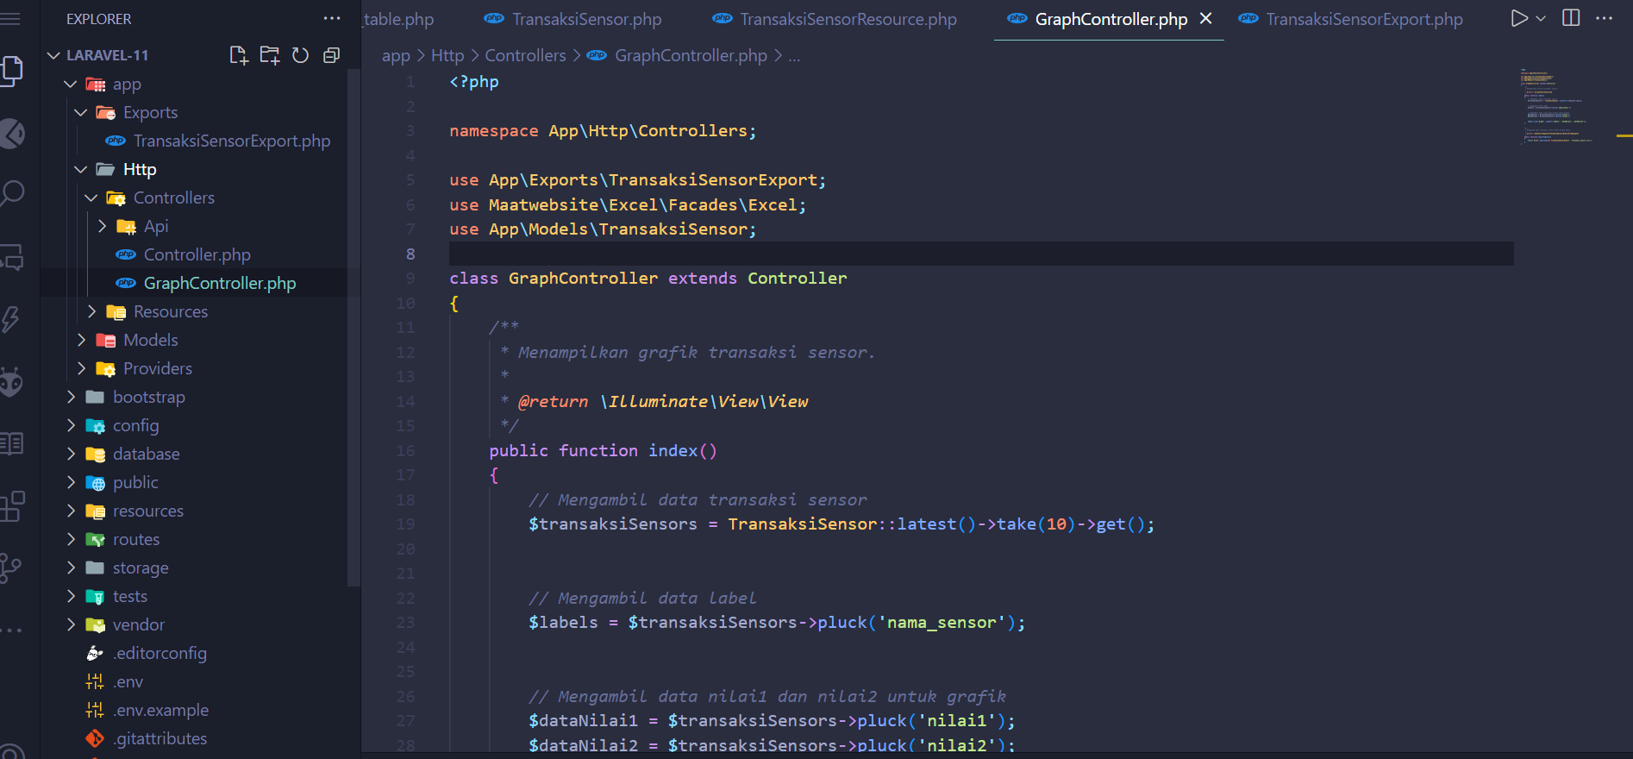

* + - 1. Kemudian, jalankan perintah ini pada terminal :

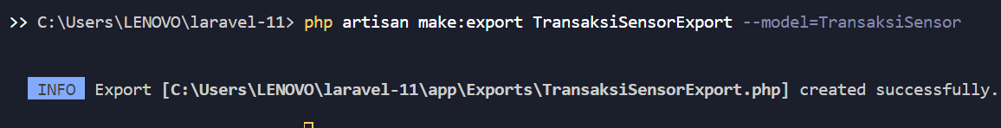

Tambahkan code berikut pada file TransaksiSensorExport :

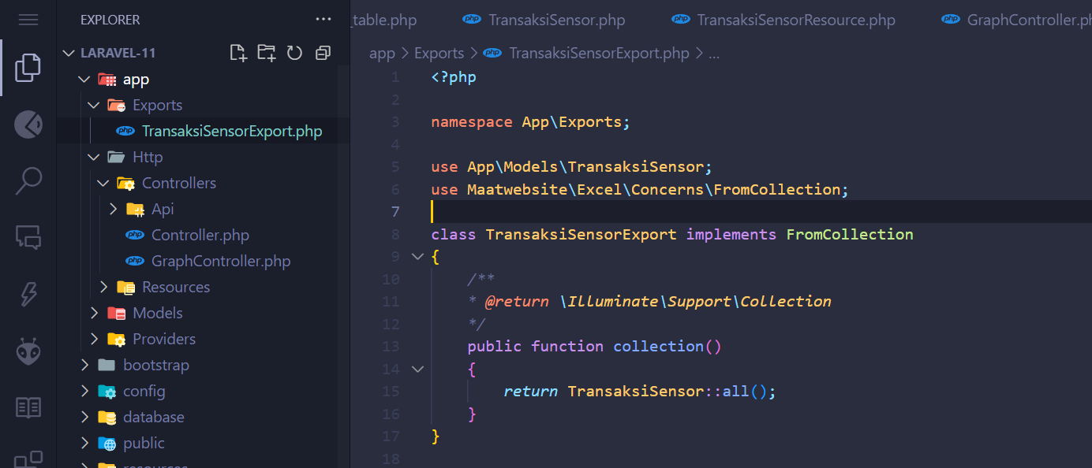

* + - 1. Setelah itu, edit file web.php yang berada di folder routes menjadi seperti berikut:

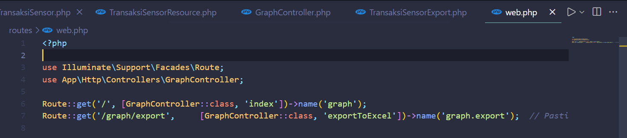

* + - 1. Setelah itu, buat file graph.blade.php pada folder resouces/views 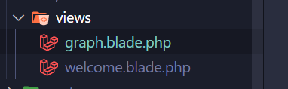

Kemudian tambahkan code berikut:

<!DOCTYPE html>

<html lang="id">

<head>

    <meta charset="UTF-8">

    <meta name="viewport" content="width=device-width, initial-scale=1.0">

    <title>Dashboard Monitoring Sensor | Sistem IoT</title>

     <link rel="stylesheet" href="https://cdnjs.cloudflare.com/ajax/libs/font-awesome/6.4.0/css/all.min.css">

     <link href="https://fonts.googleapis.com/css2?family=Poppins:wght@300;400;500;600;700&display=swap" rel="stylesheet">

    <script src="https://cdn.jsdelivr.net/npm/chart.js"></script>

    <link rel="stylesheet" href="https://cdnjs.cloudflare.com/ajax/libs/animate.css/4.1.1/animate.min.css">

    <style>

        :root {

            --primary-color: #4361ee;

            --primary-light: #e0e7ff;

            --secondary-color: #3f37c9;

            --accent-color: #4cc9f0;

            --accent-light: #e0fbfc;

            --success-color: #4bb543;

            --warning-color: #f8961e;

            --danger-color: #f94144;

            --light-color: #f8f9fa;

            --dark-color: #212529;

            --gray-color: #6c757d;

        }

        * {

            margin: 0;

            padding: 0;

            box-sizing: border-box;

        }

        body {

            font-family: 'Poppins', sans-serif;

            background: linear-gradient(135deg, #f5f7fa 0%, #e2e8f0 100%);

            min-height: 100vh;

            padding: 2rem 1rem;

            color: var(--dark-color);

            line-height: 1.6;

        }

        .dashboard-container {

            max-width: 1200px;

            margin: 0 auto;

        }

        .header {

            display: flex;

            justify-content: space-between;

            align-items: center;

            margin-bottom: 2rem;

            flex-wrap: wrap;

            gap: 1rem;

        }

        .header-title {

            font-size: 1.8rem;

            font-weight: 600;

            color: var(--primary-color);

            display: flex;

            align-items: center;

            gap: 0.75rem;

        }

        .header-title i {

            color: var(--accent-color);

        }

        .card {

            background-color: white;

            border-radius: 12px;

            box-shadow: 0 4px 20px rgba(0, 0, 0, 0.08);

            padding: 1.75rem;

            margin-bottom: 2rem;

            transition: transform 0.3s ease, box-shadow 0.3s ease;

        }

        .card:hover {

            transform: translateY(-5px);

            box-shadow: 0 8px 30px rgba(0, 0, 0, 0.12);

        }

        .card-header {

            display: flex;

            justify-content: space-between;

            align-items: center;

            margin-bottom: 1.5rem;

            padding-bottom: 1rem;

            border-bottom: 1px solid rgba(0, 0, 0, 0.05);

        }

        .card-title {

            font-size: 1.25rem;

            font-weight: 600;

            color: var(--primary-color);

            display: flex;

            align-items: center;

            gap: 0.75rem;

        }

        .card-title i {

            font-size: 1.1em;

        }

        .card-actions {

            display: flex;

            gap: 0.75rem;

        }

        .btn {

            padding: 0.5rem 1rem;

            border-radius: 8px;

            border: none;

            font-weight: 500;

            font-size: 0.9rem;

            cursor: pointer;

            transition: all 0.3s ease;

            display: inline-flex;

            align-items: center;

            gap: 0.5rem;

        }

        .btn-primary {

            background-color: var(--primary-color);

            color: white;

        }

        .btn-primary:hover {

            background-color: var(--secondary-color);

        }

        .btn-outline {

            background-color: transparent;

            border: 1px solid var(--primary-color);

            color: var(--primary-color);

        }

        .btn-outline:hover {

            background-color: var(--primary-color);

            color: white;

        }

        .btn-success {

            background-color: var(--success-color);

            color: white;

        }

        .btn-success:hover {

            opacity: 0.9;

        }

        .chart-container {

            position: relative;

            height: 400px;

            width: 100%;

            margin-bottom: 1.5rem;

        }

        .data-summary {

            display: grid;

            grid-template-columns: repeat(auto-fit, minmax(250px, 1fr));

            gap: 1.25rem;

            margin-top: 1.5rem;

        }

        .summary-card {

            background-color: white;

            border-radius: 10px;

            padding: 1.25rem;

            box-shadow: 0 2px 10px rgba(0, 0, 0, 0.05);

            transition: transform 0.2s ease;

        }

        .summary-card:hover {

            transform: translateY(-3px);

        }

        .summary-header {

            display: flex;

            justify-content: space-between;

            align-items: center;

            margin-bottom: 0.75rem;

        }

        .summary-title {

            font-size: 0.9rem;

            font-weight: 500;

            color: var(--gray-color);

        }

        .summary-icon {

            width: 36px;

            height: 36px;

            border-radius: 8px;

            display: flex;

            align-items: center;

            justify-content: center;

            font-size: 1rem;

        }

        .sensor-1 {

            background-color: var(--primary-light);

            color: var(--primary-color);

        }

        .sensor-2 {

            background-color: var(--accent-light);

            color: var(--accent-color);

        }

        .summary-value {

            font-size: 1.5rem;

            font-weight: 600;

            margin-bottom: 0.25rem;

        }

        .summary-change {

            font-size: 0.85rem;

            display: flex;

            align-items: center;

            gap: 0.25rem;

        }

        .positive {

            color: var(--success-color);

        }

        .negative {

            color: var(--danger-color);

        }

        .neutral {

            color: var(--gray-color);

        }

        .time-selector {

            display: flex;

            justify-content: flex-end;

            gap: 0.5rem;

            margin-bottom: 1rem;

        }

        .time-btn {

            padding: 0.35rem 0.75rem;

            border-radius: 6px;

            background-color: var(--light-color);

            border: none;

            font-size: 0.85rem;

            cursor: pointer;

            transition: all 0.2s ease;

        }

        .time-btn.active {

            background-color: var(--primary-color);

            color: white;

        }

        .time-btn:hover:not(.active) {

            background-color: #e9ecef;

        }

        @media (max-width: 768px) {

            .header {

                flex-direction: column;

                align-items: flex-start;

            }

            .chart-container {

                height: 300px;

            }

            .data-summary {

                grid-template-columns: 1fr;

            }

            .card-actions {

                width: 100%;

                justify-content: space-between;

            }

        }

        .fade-in {

            animation: fadeIn 0.6s ease-in-out;

        }

        @keyframes fadeIn {

            from { opacity: 0; transform: translateY(10px); }

            to { opacity: 1; transform: translateY(0); }

        }

    </style>

</head>

<body>

    <div class="dashboard-container">

        <div class="header animate__animated animate__fadeIn">

            <h1 class="header-title">

                <i class="fas fa-chart-network"></i>

                Dashboard Monitoring Sensor

            </h1>

            <div class="time-selector">

                <button class="time-btn active">24 Jam</button>

                <button class="time-btn">7 Hari</button>

                <button class="time-btn">30 Hari</button>

                <button class="time-btn">Custom</button>

            </div>

        </div>

        <div class="card animate__animated animate__fadeIn animate__delay-1s">

            <div class="card-header">

                <h2 class="card-title">

                    <i class="fas fa-wave-square"></i>

                    Grafik Perbandingan Sensor

                </h2>

                <div class="card-actions">

                    <button class="btn btn-outline" onclick="window.location.href='{{ route('graph.export') }}'">

                        <i class="fas fa-download"></i> Export

                    </button>

                </div>

            </div>

            <div class="chart-container">

                <canvas id="sensorChart"></canvas>

            </div>

            <div class="data-summary">

                <div class="summary-card fade-in">

                    <div class="summary-header">

                        <span class="summary-title">Sensor 1 (Rata-rata)</span>

                        <div class="summary-icon sensor-1">

                            <i class="fas fa-thermometer-half"></i>

                        </div>

                    </div>

                    <div class="summary-value" id="avg-sensor1">0</div>

                    <div class="summary-change positive">

                        <i class="fas fa-arrow-up"></i> <span id="change-sensor1">0%</span> dari periode sebelumnya

                    </div>

                </div>

                <div class="summary-card fade-in">

                    <div class="summary-header">

                        <span class="summary-title">Sensor 2 (Rata-rata)</span>

                        <div class="summary-icon sensor-2">

                            <i class="fas fa-thermometer-quarter"></i>

                        </div>

                    </div>

                    <div class="summary-value" id="avg-sensor2">0</div>

                    <div class="summary-change negative">

                        <i class="fas fa-arrow-down"></i> <span id="change-sensor2">0%</span> dari periode sebelumnya

                    </div>

                </div>

                <div class="summary-card fade-in">

                    <div class="summary-header">

                        <span class="summary-title">Korelasi</span>

                        <div class="summary-icon">

                            <i class="fas fa-link"></i>

                        </div>

                    </div>

                    <div class="summary-value" id="correlation-value">0.00</div>

                    <div class="summary-change neutral">

                        <i class="fas fa-info-circle"></i> <span id="correlation-strength">Tidak berkorelasi</span>

                    </div>

                </div>

            </div>

        </div>

    </div>

    <script>

        const labels = @json($labels);

        const dataNilai1 = @json($dataNilai1);

        const dataNilai2 = @json($dataNilai2);

        function calculateStats(data) {

            const sum = data.reduce((a, b) => a + b, 0);

            const avg = sum / data.length;

            const max = Math.max(...data);

            const min = Math.min(...data);

            return { sum, avg, max, min };

        }

        function calculateCorrelation(x, y) {

            const n = x.length;

            let sumX = 0, sumY = 0, sumXY = 0, sumX2 = 0, sumY2 = 0;

            for (let i = 0; i < n; i++) {

                sumX += x[i];

                sumY += y[i];

                sumXY += x[i] * y[i];

                sumX2 += x[i] * x[i];

                sumY2 += y[i] * y[i];

            }

            const numerator = sumXY - (sumX * sumY) / n;

            const denominator = Math.sqrt((sumX2 - (sumX * sumX) / n) * (sumY2 - (sumY * sumY) / n));

            return denominator === 0 ? 0 : numerator / denominator;

        }

        const stats1 = calculateStats(dataNilai1);

        const stats2 = calculateStats(dataNilai2);

        const correlation = calculateCorrelation(dataNilai1, dataNilai2);

        document.getElementById('avg-sensor1').textContent = stats1.avg.toFixed(2);

        document.getElementById('avg-sensor2').textContent = stats2.avg.toFixed(2);

        document.getElementById('change-sensor1').textContent = (Math.random() * 5).toFixed(1) + '%';

        document.getElementById('change-sensor2').textContent = (Math.random() * 3).toFixed(1) + '%';

        document.getElementById('correlation-value').textContent = correlation.toFixed(2);

        const correlationStrength = document.getElementById('correlation-strength');

        if (Math.abs(correlation) > 0.7) {

            correlationStrength.textContent = 'Korelasi kuat';

            correlationStrength.className = 'positive';

        } else if (Math.abs(correlation) > 0.3) {

            correlationStrength.textContent = 'Korelasi sedang';

            correlationStrength.className = 'neutral';

        } else {

            correlationStrength.textContent = 'Korelasi lemah';

            correlationStrength.className = 'negative';

        }

        const ctx = document.getElementById('sensorChart').getContext('2d');

        const chart = new Chart(ctx, {

            type: 'line',

            data: {

                labels: labels,

                datasets: [

                    {

                        label: 'Sensor 1',

                        data: dataNilai1,

                        borderColor: '#4361ee',

                        backgroundColor: 'rgba(67, 97, 238, 0.1)',

                        borderWidth: 2,

                        tension: 0.3,

                        fill: true,

                        pointBackgroundColor: 'white',

                        pointBorderColor: '#4361ee',

                        pointBorderWidth: 2,

                        pointRadius: 4,

                        pointHoverRadius: 6,

                        yAxisID: 'y'

                    },

                    {

                        label: 'Sensor 2',

                        data: dataNilai2,

                        borderColor: '#4cc9f0',

                        backgroundColor: 'rgba(76, 201, 240, 0.1)',

                        borderWidth: 2,

                        tension: 0.3,

                        fill: true,

                        pointBackgroundColor: 'white',

                        pointBorderColor: '#4cc9f0',

                        pointBorderWidth: 2,

                        pointRadius: 4,

                        pointHoverRadius: 6,

                        yAxisID: 'y'

                    }

                ]

            },

            options: {

                responsive: true,

                maintainAspectRatio: false,

                interaction: {

                    mode: 'index',

                    intersect: false

                },

                plugins: {

                    legend: {

                        position: 'top',

                        labels: {

                            usePointStyle: true,

                            padding: 20,

                            font: {

                                size: 13,

                                weight: '500'

                            }

                        }

                    },

                    tooltip: {

                        backgroundColor: 'rgba(0, 0, 0, 0.85)',

                        titleFont: {

                            size: 14,

                            weight: '600'

                        },

                        bodyFont: {

                            size: 13

                        },

                        padding: 12,

                        cornerRadius: 8,

                        usePointStyle: true,

                        callbacks: {

                            label: function(context) {

                                let label = context.dataset.label || '';

                                if (label) {

                                    label += ': ';

                                }

                                if (context.parsed.y !== null) {

                                    label += context.parsed.y.toFixed(2);

                                }

                                return label;

                            }

                        }

                    },

                    annotation: {

                        annotations: {

                            line1: {

                                type: 'line',

                                yMin: stats1.avg,

                                yMax: stats1.avg,

                                borderColor: '#4361ee',

                                borderWidth: 1,

                                borderDash: [5, 5],

                                label: {

                                    content: 'Rata-rata S1: ' + stats1.avg.toFixed(2),

                                    enabled: true,

                                    position: 'right',

                                    backgroundColor: 'rgba(67, 97, 238, 0.7)'

                                }

                            },

                            line2: {

                                type: 'line',

                                yMin: stats2.avg,

                                yMax: stats2.avg,

                                borderColor: '#4cc9f0',

                                borderWidth: 1,

                                borderDash: [5, 5],

                                label: {

                                    content: 'Rata-rata S2: ' + stats2.avg.toFixed(2),

                                    enabled: true,

                                    position: 'right',

                                    backgroundColor: 'rgba(76, 201, 240, 0.7)'

                                }

                            }

                        }

                    }

                },

                scales: {

                    y: {

                        beginAtZero: false,

                        grid: {

                            color: 'rgba(0, 0, 0, 0.05)'

                        },

                        ticks: {

                            font: {

                                size: 12

                            }

                        }

                    },

                    x: {

                        grid: {

                            display: false

                        },

                        ticks: {

                            font: {

                                size: 12

                            }

                        }

                    }

                },

                animation: {

                    duration: 1000,

                    easing: 'easeOutQuart'

                }

            }

        });

        // Time selector functionality

        document.querySelectorAll('.time-btn').forEach(btn => {

            btn.addEventListener('click', function() {

                document.querySelectorAll('.time-btn').forEach(b => b.classList.remove('active'));

                this.classList.add('active');

                chart.data.datasets.forEach(dataset => {

                    dataset.data = dataset.data.map(() => Math.random() * 100);

                });

                chart.update();

            });

        });

        window.addEventListener('resize', function() {

            chart.resize();

        });

    </script>

</body>

</html>

* + - 1. Setelah semuanya sudah, jalankan program tersebut dengan perintah berikut:

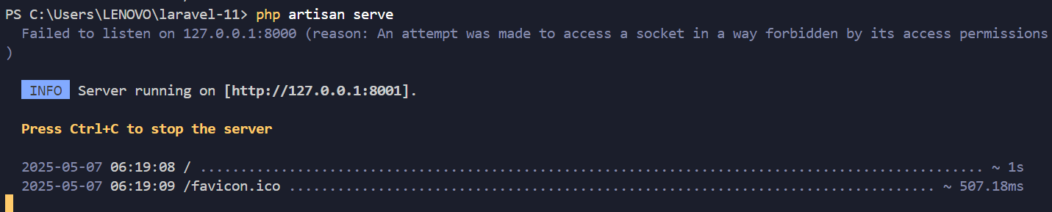

Maka dapat melihat grafik data berdasarkan dari database iot_25 seperti berikut:

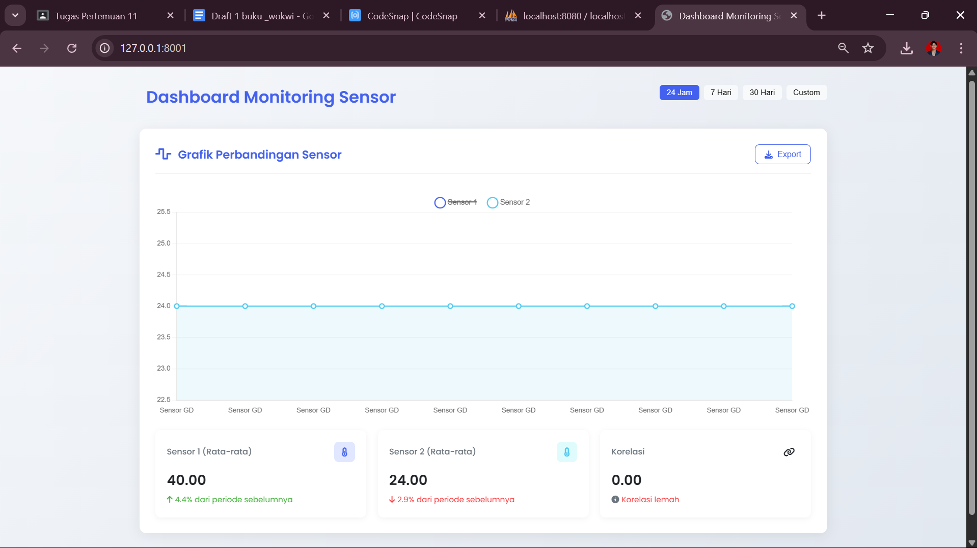

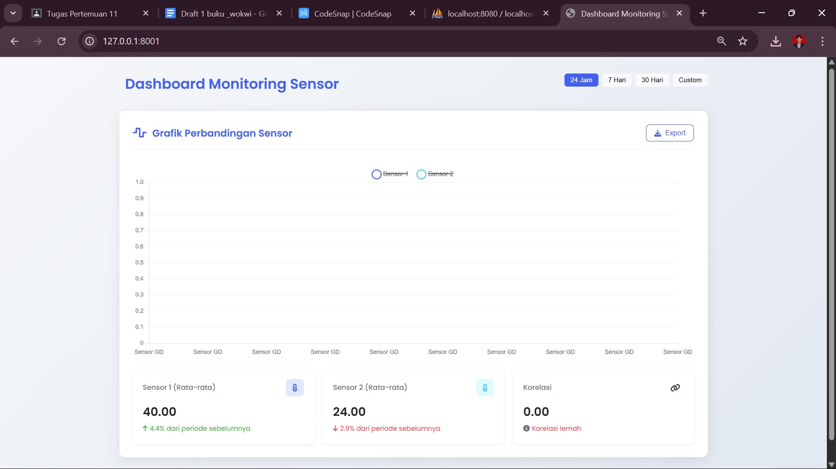

1. Results and Discussion
   1. Experimental Results



